Test Case: tc002_SPX_Dev5_Crear_Requisicion_Spot_Con_FAD_Tipo_Cobro_CC
Step 1 - Enter username and password and click to button Enter : Credentials Entered
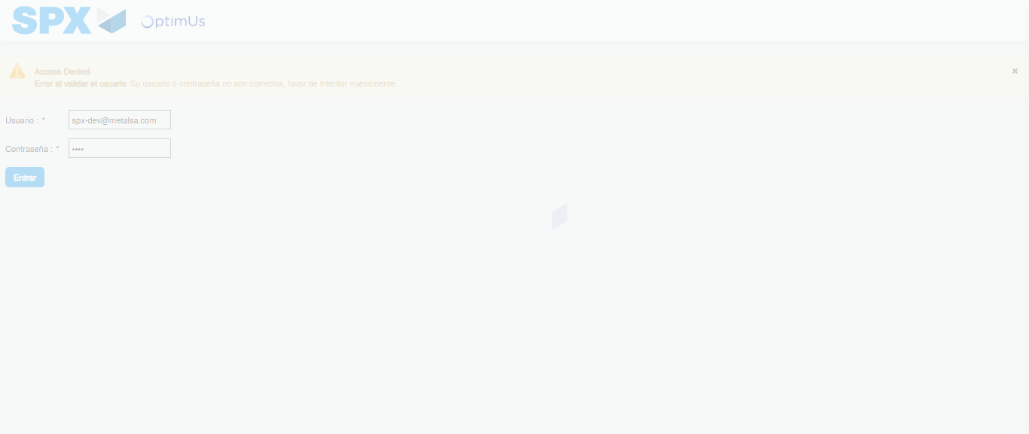Image file-name: QC_Testing-tc002_SPX_Dev5_Crear_Requisicion_Spot_Con_FAD_Tipo_Cobro_CC-1790175554575

Step 2 - Select to UEN and Access to Spot Buy Requisitions : UEN Correctly selected and Correct access
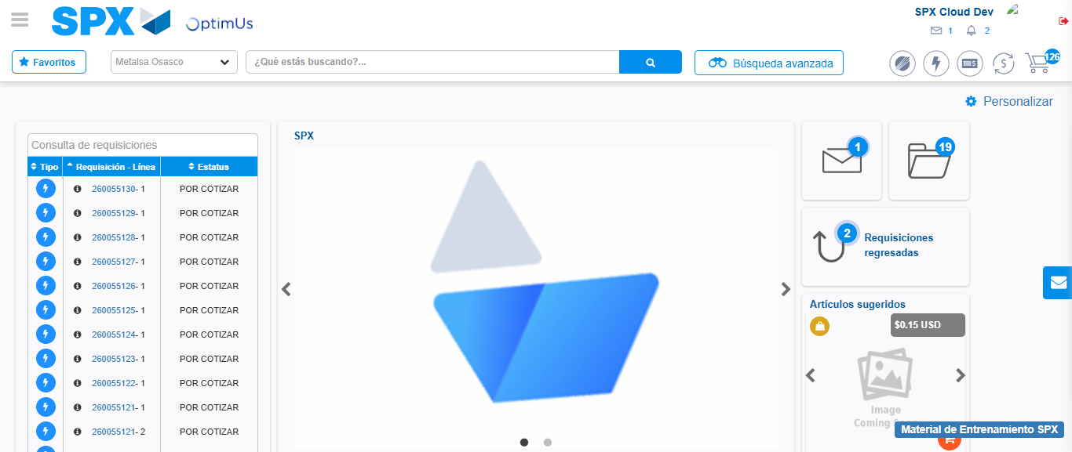Image file-name: QC_Testing-tc002_SPX_Dev5_Crear_Requisicion_Spot_Con_FAD_Tipo_Cobro_CC-1790175578210

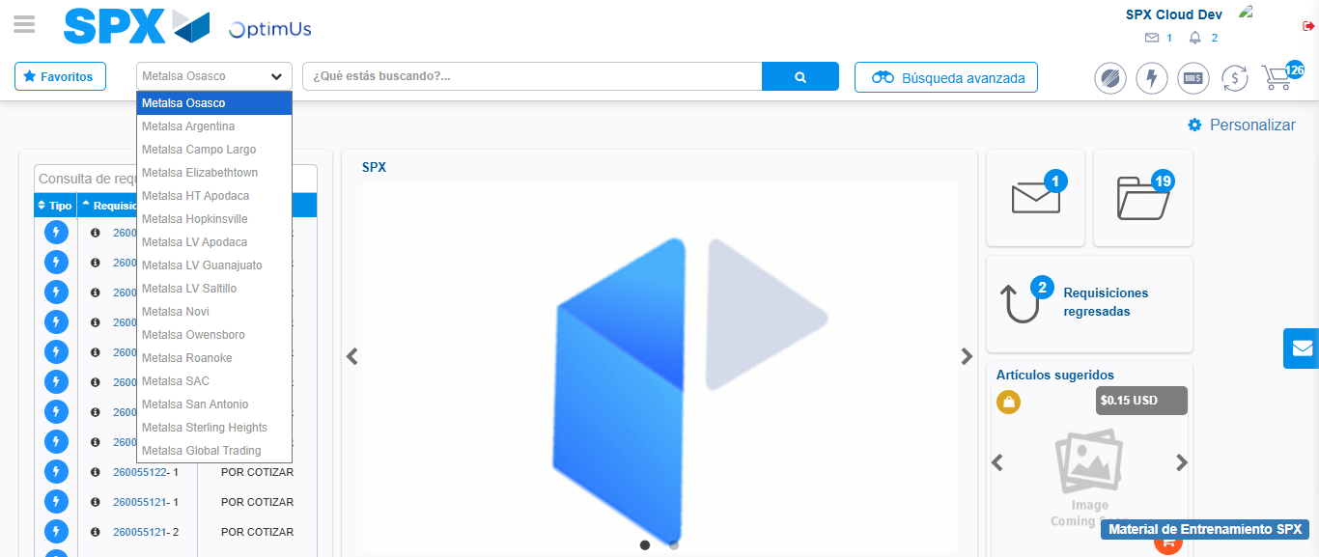Image file-name: QC_Testing-tc002_SPX_Dev5_Crear_Requisicion_Spot_Con_FAD_Tipo_Cobro_CC-1790175578739

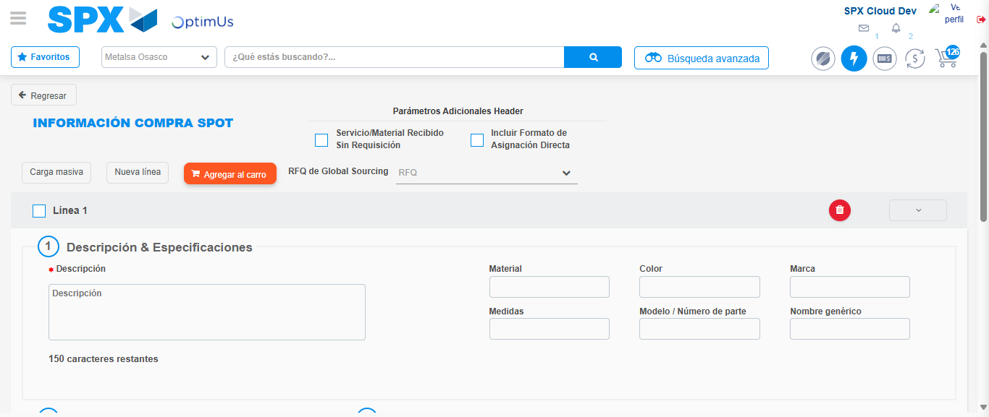Image file-name: QC_Testing-tc002_SPX_Dev5_Crear_Requisicion_Spot_Con_FAD_Tipo_Cobro_CC-1790175582678

Step 3 - Add FAD to Requisition: FAD Successfully Added
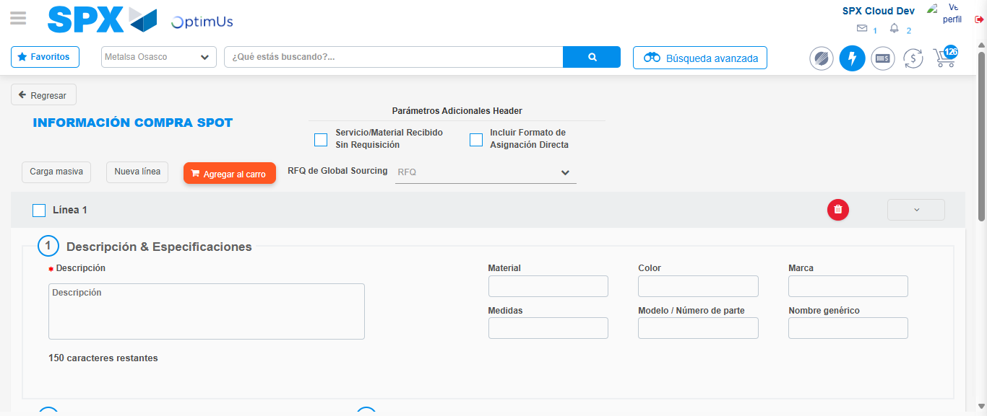Image file-name: QC_Testing-tc002_SPX_Dev5_Crear_Requisicion_Spot_Con_FAD_Tipo_Cobro_CC-1790175582950

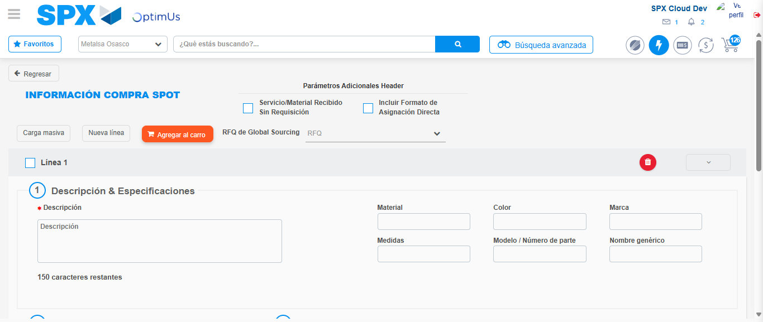Image file-name: QC_Testing-tc002_SPX_Dev5_Crear_Requisicion_Spot_Con_FAD_Tipo_Cobro_CC-1790175583190

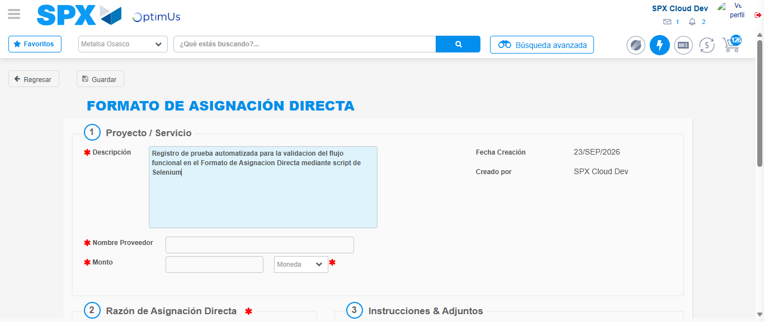Image file-name: QC_Testing-tc002_SPX_Dev5_Crear_Requisicion_Spot_Con_FAD_Tipo_Cobro_CC-1790175585842

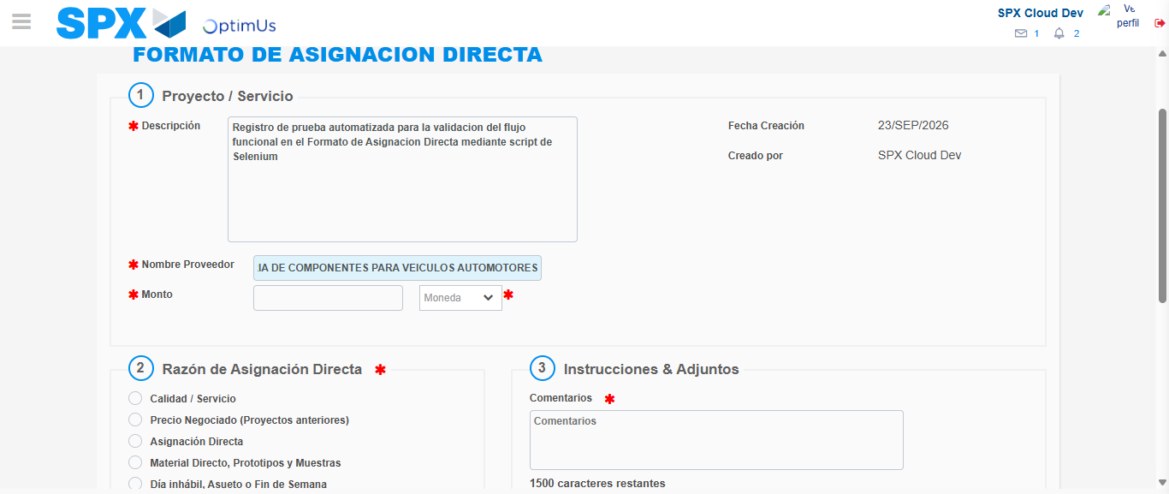Image file-name: QC_Testing-tc002_SPX_Dev5_Crear_Requisicion_Spot_Con_FAD_Tipo_Cobro_CC-1790175594109

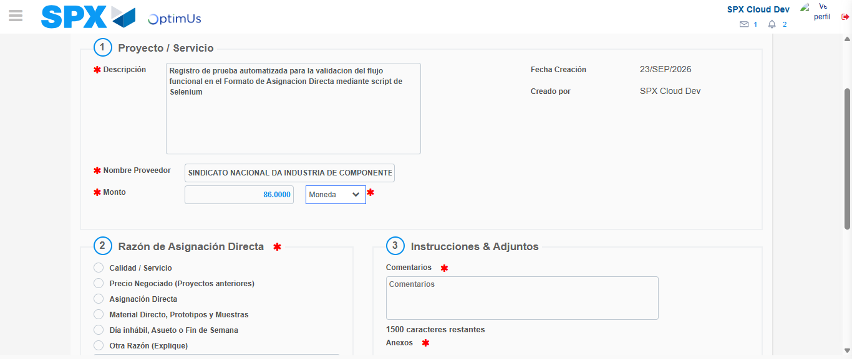Image file-name: QC_Testing-tc002_SPX_Dev5_Crear_Requisicion_Spot_Con_FAD_Tipo_Cobro_CC-1790175594414

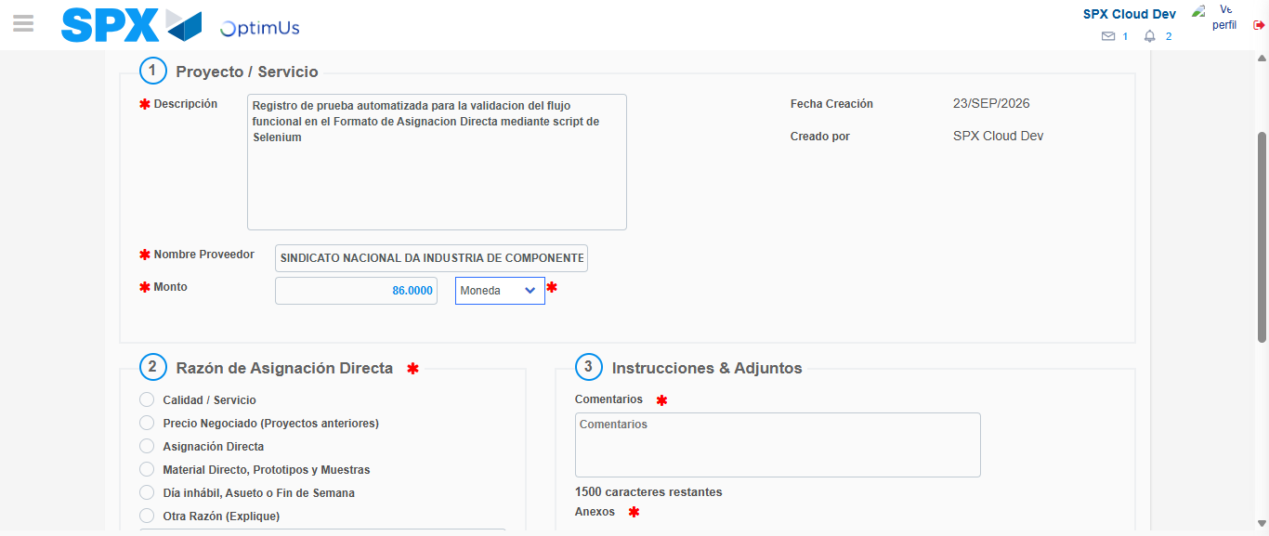Image file-name: QC_Testing-tc002_SPX_Dev5_Crear_Requisicion_Spot_Con_FAD_Tipo_Cobro_CC-1790175594606

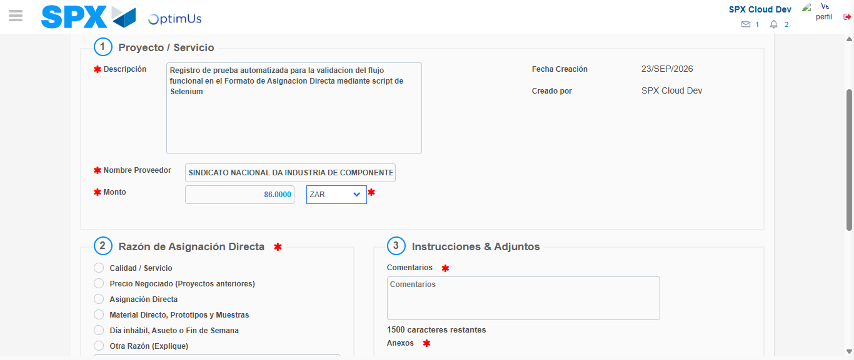Image file-name: QC_Testing-tc002_SPX_Dev5_Crear_Requisicion_Spot_Con_FAD_Tipo_Cobro_CC-1790175594906

Image file-name: QC_Testing-tc002_SPX_Dev5_Crear_Requisicion_Spot_Con_FAD_Tipo_Cobro_CC-1790175595098

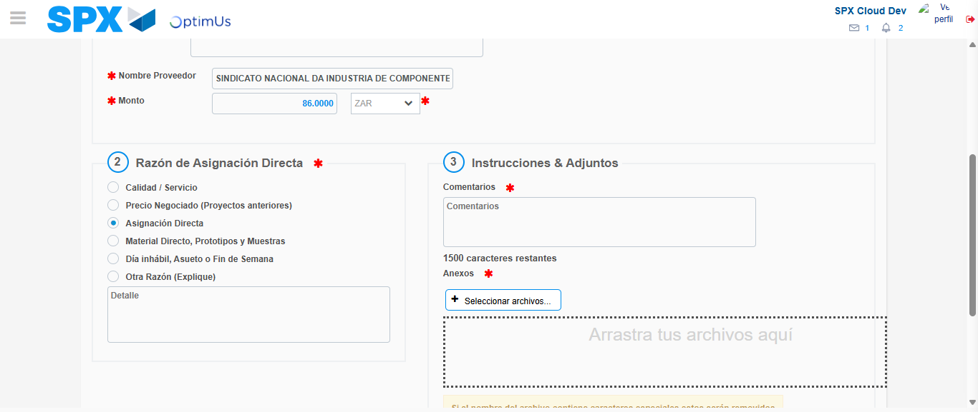Image file-name: QC_Testing-tc002_SPX_Dev5_Crear_Requisicion_Spot_Con_FAD_Tipo_Cobro_CC-1790175595873

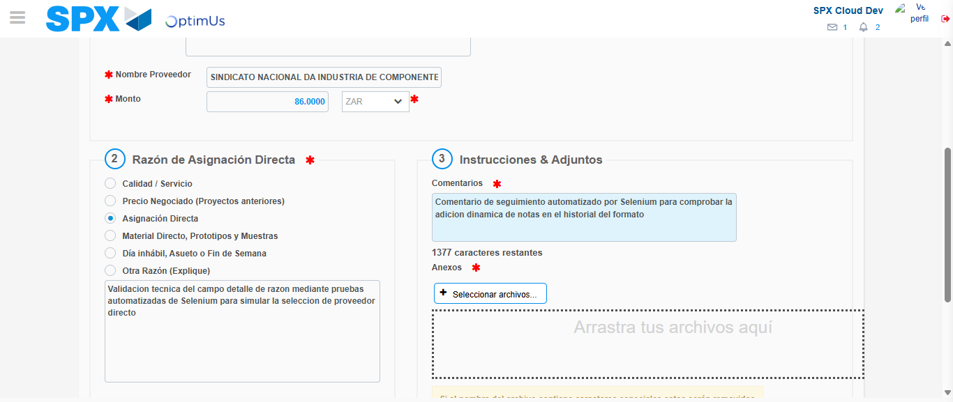Image file-name: QC_Testing-tc002_SPX_Dev5_Crear_Requisicion_Spot_Con_FAD_Tipo_Cobro_CC-1790175606804

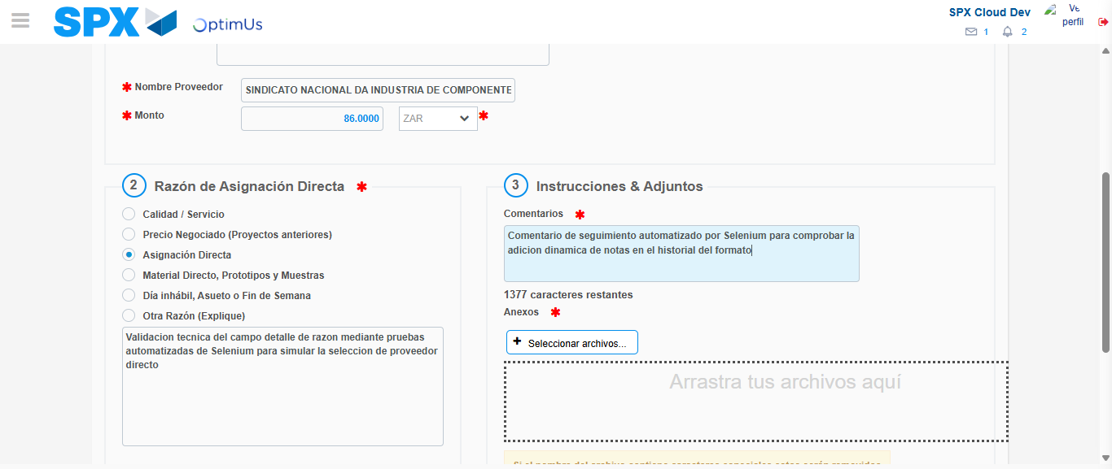Image file-name: QC_Testing-tc002_SPX_Dev5_Crear_Requisicion_Spot_Con_FAD_Tipo_Cobro_CC-1790175607351

Step 4 - Data Capture Spot Buy Requisition: Data captured correctly
Image file-name: QC_Testing-tc002_SPX_Dev5_Crear_Requisicion_Spot_Con_FAD_Tipo_Cobro_CC-1790175582950

Image file-name: QC_Testing-tc002_SPX_Dev5_Crear_Requisicion_Spot_Con_FAD_Tipo_Cobro_CC-1790175583190

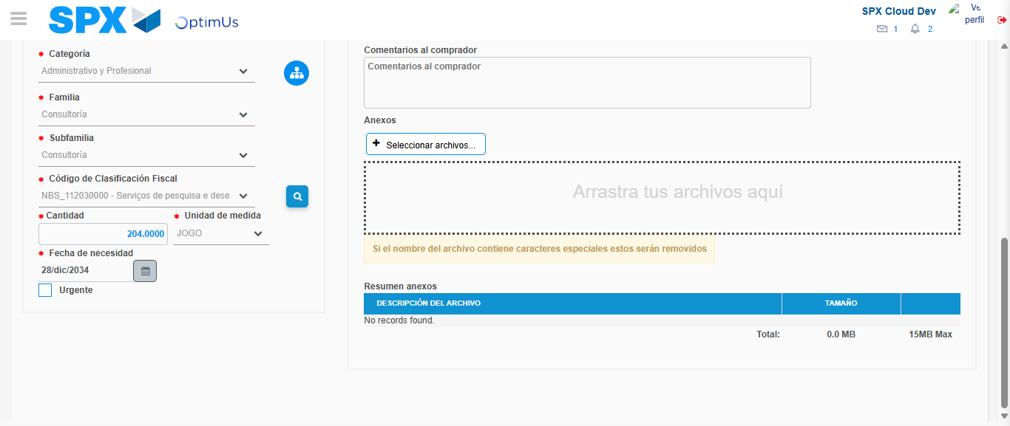Image file-name: QC_Testing-tc002_SPX_Dev5_Crear_Requisicion_Spot_Con_FAD_Tipo_Cobro_CC-1790175629864

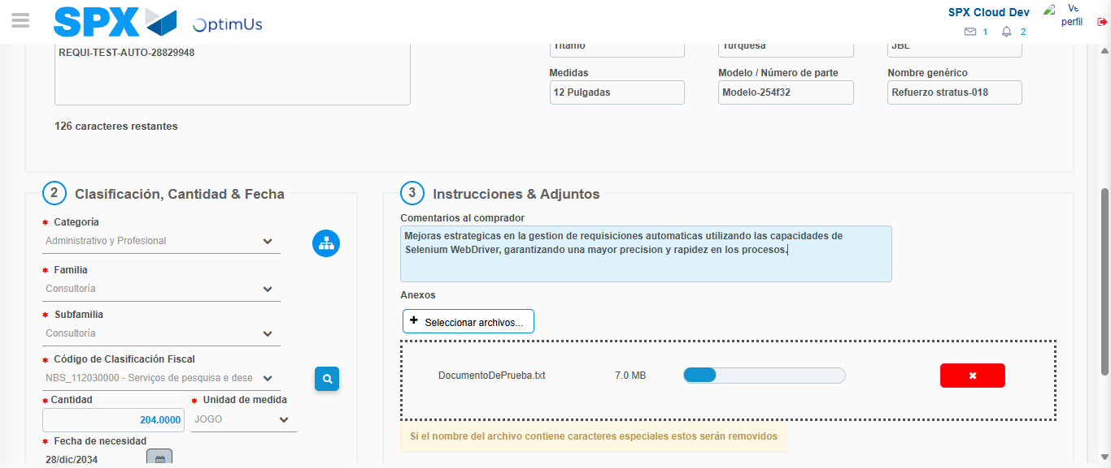Image file-name: QC_Testing-tc002_SPX_Dev5_Crear_Requisicion_Spot_Con_FAD_Tipo_Cobro_CC-1790175630607

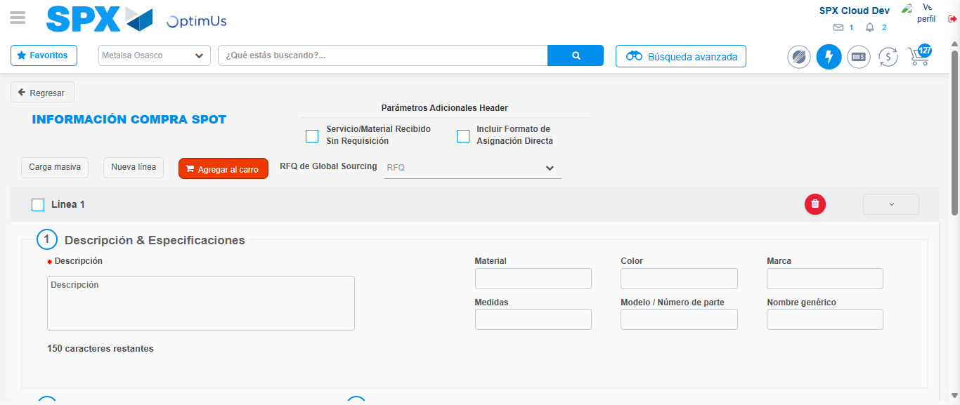Image file-name: QC_Testing-tc002_SPX_Dev5_Crear_Requisicion_Spot_Con_FAD_Tipo_Cobro_CC-1790175647741

Step 8 - Return to Main Page SPX : Return to Main Page SPX
Image file-name: QC_Testing-tc002_SPX_Dev5_Crear_Requisicion_Spot_Con_FAD_Tipo_Cobro_CC-1790175578210

Image file-name: QC_Testing-tc002_SPX_Dev5_Crear_Requisicion_Spot_Con_FAD_Tipo_Cobro_CC-1790175578739

Image file-name: QC_Testing-tc002_SPX_Dev5_Crear_Requisicion_Spot_Con_FAD_Tipo_Cobro_CC-1790175582678

Image file-name: QC_Testing-tc002_SPX_Dev5_Crear_Requisicion_Spot_Con_FAD_Tipo_Cobro_CC-1790175649982

Image file-name: QC_Testing-tc002_SPX_Dev5_Crear_Requisicion_Spot_Con_FAD_Tipo_Cobro_CC-1790175650171

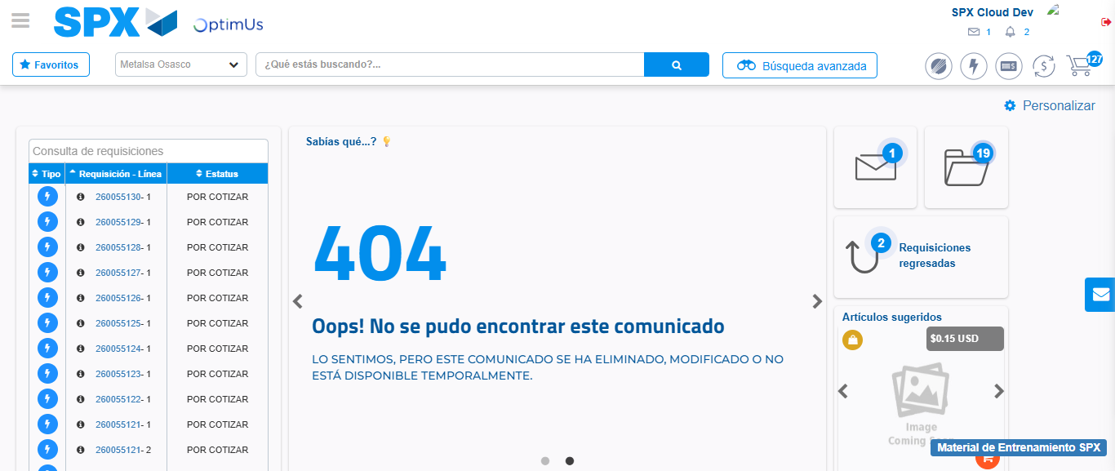Image file-name: QC_Testing-tc002_SPX_Dev5_Crear_Requisicion_Spot_Con_FAD_Tipo_Cobro_CC-1790175672170

Step 9 - Log Out : Log Out SPX
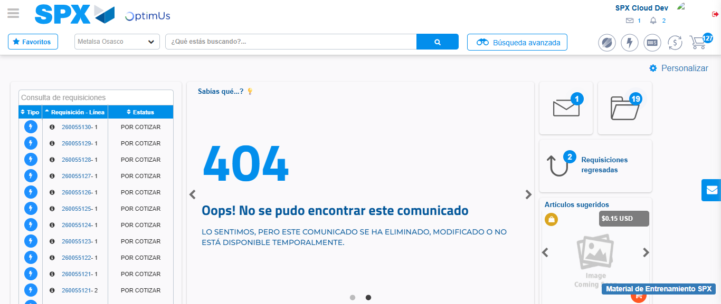Image file-name: QC_Testing-tc002_SPX_Dev5_Crear_Requisicion_Spot_Con_FAD_Tipo_Cobro_CC-1790175672486

